Lab: ThreatConncet Setup

Go to the web site **Threatconnect** login and create account click https://app.threatconnect.com/

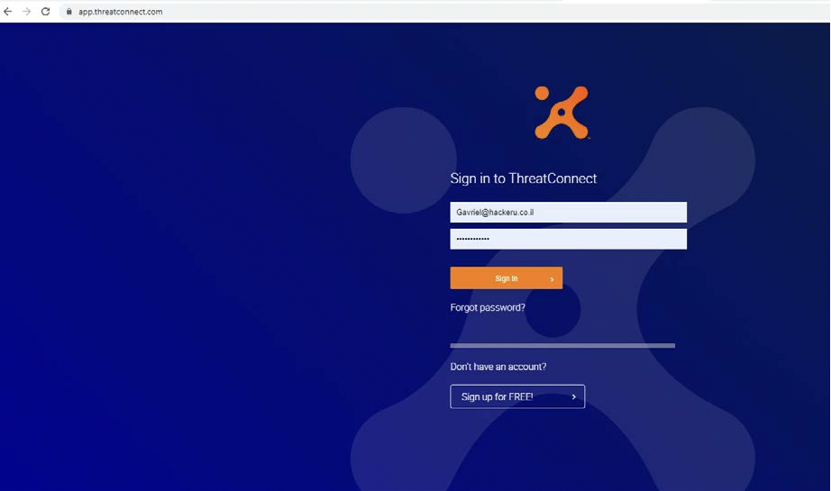

In the website threatconnect look for **Mimikatz** or **BloodHound**,

On the left side of the site, we have fields that can be filtered - for example, we want to get information about **MIMIKATZ**  
You can wrote it down in the search  
Then V marks a URL and I get results

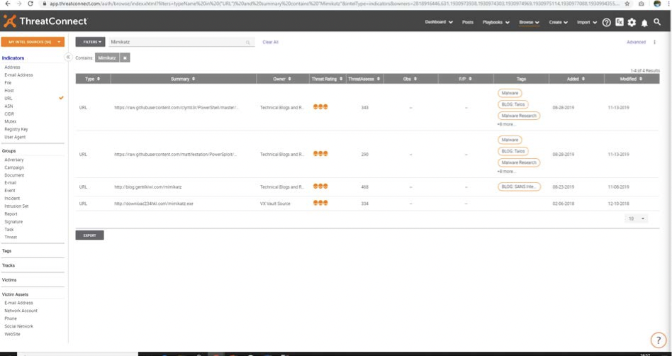

Double click on the first resolved and you get more details about For the threat she was looking for.

To know how to use **Threatconnect** go to

https://threatconnect.com/blog/tag/threatconnect/

